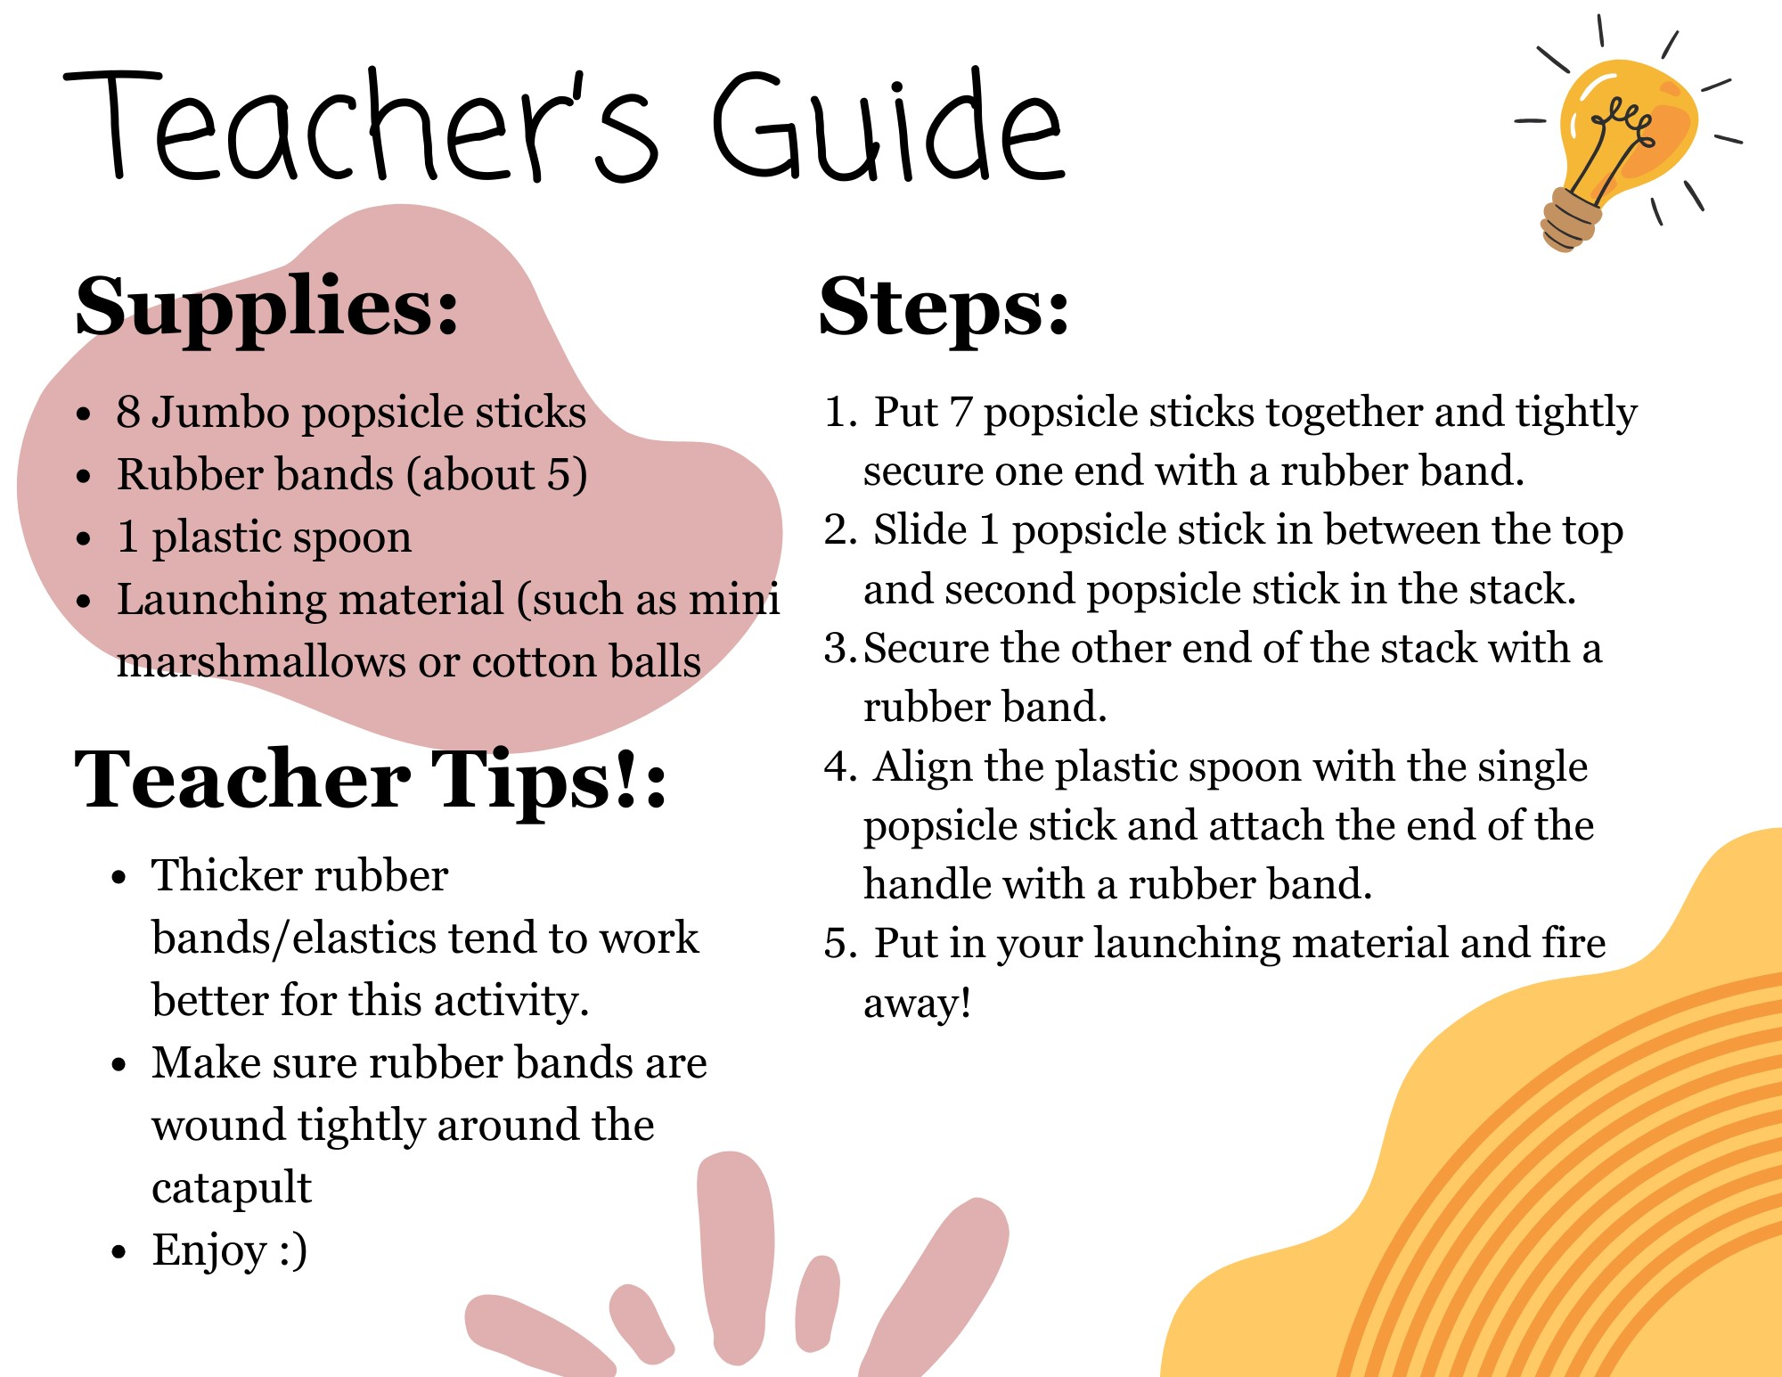
SOL Science Activity Modifications:
For each science strand we study, chose a grade level and activity from VDOE website for sample lesson plans and activities. https://www.doe.virginia.gov/testing/sol/standardsdocs/science/2010/lesson_plans/index.shtml

Please complete the table below.

Science Strand | Force, Motion, Energy
Name of the Activity | Making a catapult (simple machine)
SOL/Grade level | 2.2 The student will investigate and understand that different types of forces may cause an object’s motion to change. Key ideas include a) forces from direct contact can cause an object to move; b) some forces, including gravity and magnetism, can cause objects to move from a distance; and c) forces have applications in our lives
Process Skills or “Investigative” Skills | List the process skills/investigative skill used in this activity. Phrase the investigative/process skills as you would for an objective.  TSW _compare this simple machine to what they know of a compound machine _____(insert investigative/process skills verb)  TSW__define what a simple machine_is_____  TSW_apply their knowledge to a hands on activity (building the catapult)_________  TSW__investigate characteristics of the simple machine________
Questioning Strategies | As you read through the activity, include sample questions you could ask to make the activity more engaging for students and to check for understanding. Refer to the questioning strategies handout.  Start with attention focusing, comparing/contrasting, measuring, and action questions before moving to problem posing ones. You will have a lot more attention focusing questions when you are starting off a lesson and you may not reach the higher level of problem posing questions in one lesson, especially with kindergarteners.  Attention focusing:  Have you seen a catapult before?  What do you think this will do?  Comparing/contrasting:  What type of machine would you classify this as?  How is it is similar/different than a compound machine?  Measuring:  How far do you think are marshmallows will go?  Do you think the number of rubber bands would change the force on this machine?  Action:  What happens if you apply more force?  What happens if you don’t pull it all the way down?
Multiple Intelligences | Include all the multiple intelligences used and the specific activities that are used with these multiple intelligences.  Bodily kinesthetic – using their hands to build, getting up when using the catapult  Interpersonal – comparing their catapult with classmates  Intrapersonal – reflecting on how it works, what you could change, etc.
